Linear Regression:

Simple y = b0 +b­1­*x

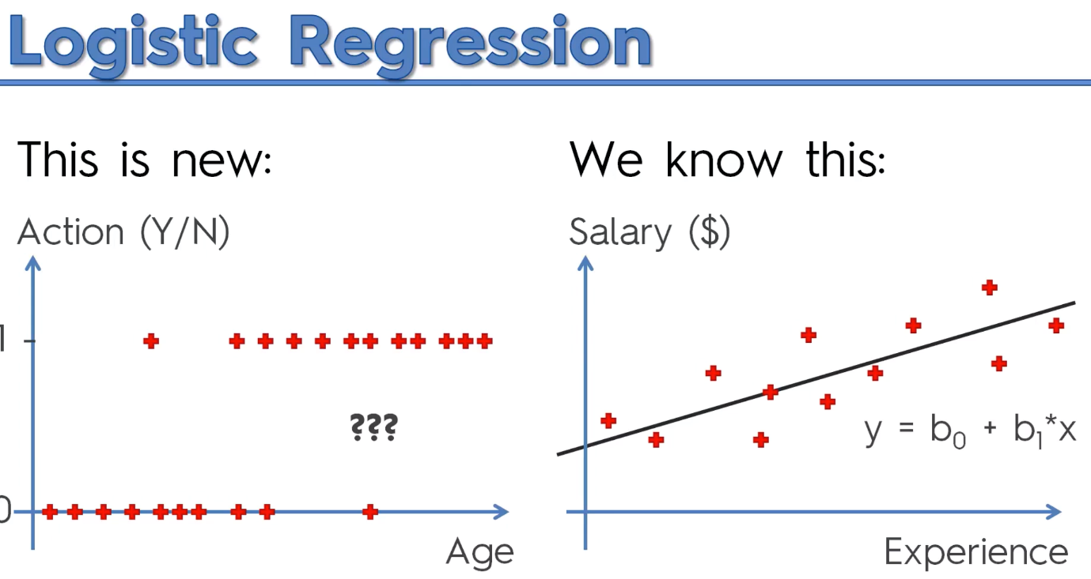Multiple y = b0 + b1*x1 + …. + bn*xn

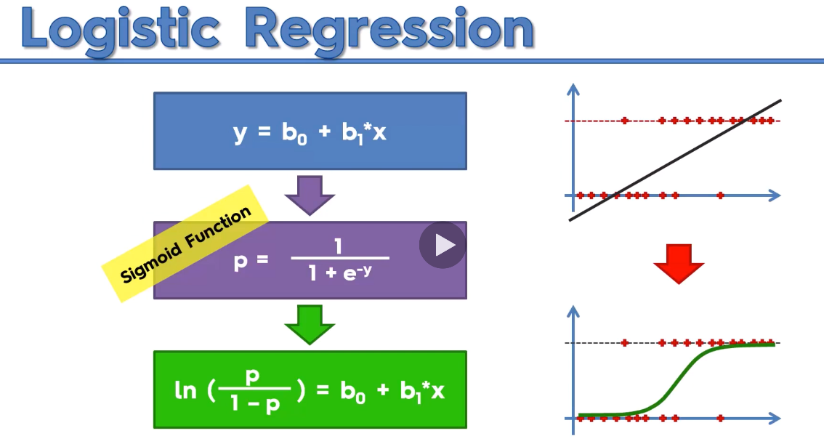Try to predict the probability of YES Action

Apply a linear function with a Sigmoid Function. Logistic Regression Formula. Slope or trendline for a linear regression. Use it to predict the Probability

P^ - p_hat its something that we are predicting.

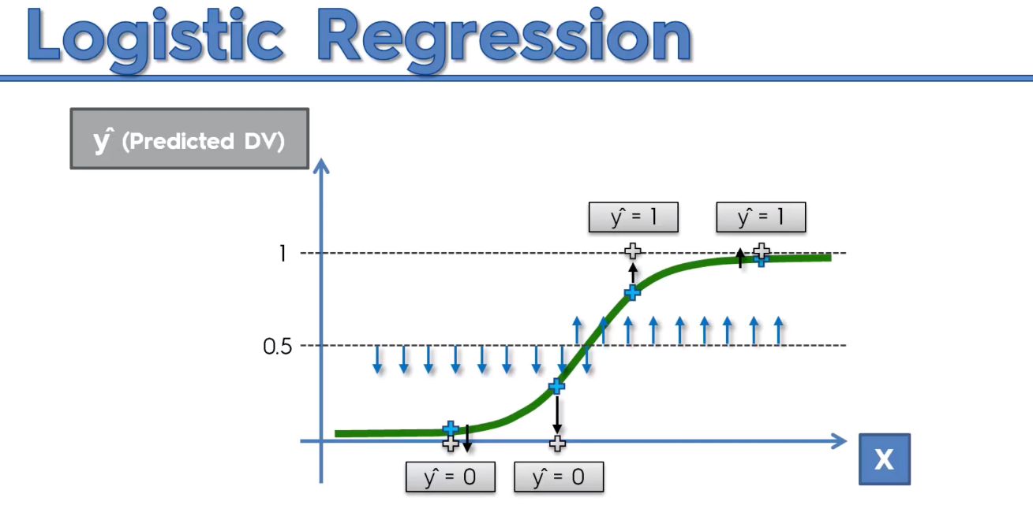 Guide

<https://www.superdatascience.com/blogs/the-ultimate-guide-to-regression-classification>

<https://www.udemy.com/course/logistic-regression-cancer-detection-case-study/?referralCode=7E62BC258B645C95D9F5>